Join us for our 2020
This Photo by Unknown Author is licensed under CC BY
Brooks Golf Customer Appreciation Day
Brooks Golf is grateful to our Season Pass Holders and Tournament Directors for choosing us as your Home. So a big THANK YOU for your support!
We would like to invite our Season Golf Pass Holders and Tournament Directors to this fun and relaxing 18 Hole 4 Player Team Scramble. Event information:

Date: Saturday, October 3rd
Time: 12:00 Shotgun Start
Cost: $10/ Player (For food & prizes)

Optional Skins Game: $20/Team
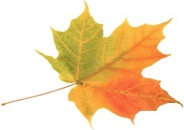 (Note: Cash Bar for Alcoholic Beverages)
This Photo by Unknown Author is licensed under CC BY

You may make your own 4 Player Team with other Season Golf Pass Holders. We will also try to pair to make full teams. All Tournament Directors may bring a Foursome. Please sign up by calling or stopping by The Golf Shop.
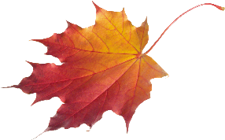
This Photo by Unknown Author is licensed under CC BY-NC

